1. Complete the sentences:
Biodiversity means the ________________ of living things
Cutting down trees is called ____________________
Growing only one crop reduces ________________
(word bank: deforestation / variety / biodiversity)
2. How Humans Harm Biodiversity  Tick TWO:  ☐ Cutting trees  ☐ Planting more trees  ☐ Polluting rivers  ☐ Protecting rare habitats  4. Complete the sentences  We need biodiversity because ___________________________________________________________  The demand for resources has increased because________________________________________ | 3. How Humans Help Biodiversity  Choose TWO and circle:  ♻️ Recycling  🌼 Growing hedgerows  🌲 Deforestation  🌪 Destroying habitats

Word | Meaning
Biodiversity | The place where plants and animals live
Habitat | A community of living things and their environment
Ecosystem | The variety of living things in an area
5.

6. State one thing farmers can do to improve biodiversity.
__________________________________________________________________________
7. State one thing zoos can do to improve biodiversity.
__________________________________________________________________________
8. State two other actions humans can take to improve biodiversity.
__________________________________________________
__________________________________________________
9. State one way deforestation can increase carbon dioxide levels in the atmosphere.
__________________________________________________________________________

10. Complete the table by organise the following actions into the correct column to decide what effect they could have on biodiversity:

(Write the number in the box)
- Building and maintaining nature reserves
- Rainforest habitat destruction
- Bringing new species into a habitat
- Helping endangered animals have babies so their numbers increase
- Hunting and fishing quotas
- Vaccinating against specific diseases
- Removing hedgerows (Cutting down hedges that give food and shelter to birds and insects)
Increase Biodiversity | Decrease Biodiversity | Could increase or decrease Biodiversity

11. Pick ONE action that could increase or decrease biodiversity explain your reasoning.
____________________________________________________________________________________________________________________________________________________________________________________________________________________________________

Draw or write one way YOU can help protect biodiversity.

Read Now: How Biodiversity Can Be Measured Date:09/01/2026
Biodiversity means the variety of living things in an area.
Scientists need to measure biodiversity to find out how healthy a habitat is.
Biodiversity can be measured in two main ways:

Count how many different species there are: If a place has many different species, biodiversity is high. If there are only a few species, biodiversity is low.

Count how many of each species are there: Scientists also count how many individuals belong to each species.

For example, they might count how many daisies and buttercups are in a patch. A habitat with lots of the same species may still have low biodiversity.
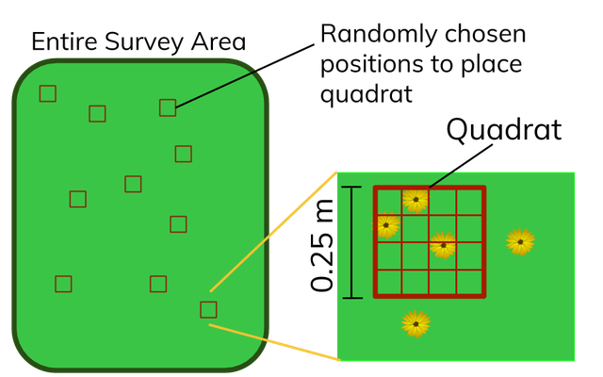
Scientists cannot count every organism as it would take too long.
Instead, they collect data using sampling. They use a quadrat, a square frame placed on the ground.
Scientists count the species inside the quadrat and use the data to estimate the whole area. Quadrats are placed randomly to give fair and unbiased results.
Questions
- (Circle one) Biodiversity means:
A. The colour of plants B. The height of trees
C. The variety of living things in an area D. How fast animals move

- Scientists measure biodiversity to find out how _____________ a habitat is.
- If there are many different species in an area, biodiversity is _____________.
- Why do scientists use quadrats instead of counting every organism? Write one reason.

- Look at the quadrat in the image above. How many flowers are inside the quadrat?

- A scientist places a quadrat randomly and counts:
5 buttercups, 4 daisies and 3 clover plants
What does this tell you about the biodiversity in the quadrat? Explain your answer using the numbers above.

1. Complete the sentences
Biodiversity means the variety of living things ✔️
Cutting down trees is called deforestation ✔️
Growing only one crop reduces biodiversity ✔️
(Each worth 1 mark)

2. How Humans Harm Biodiversity
Tick TWO:
✔ Cutting trees
✔ Polluting rivers
(Planting trees and protecting habitats are positive actions — must NOT be ticked)
(2 marks – both correct needed)

3. How Humans Help Biodiversity
Circle TWO:
✔ Recycling
✔ Growing hedgerows
✔ Planting trees
✘ Destroying habitats should NOT be circled
(2 marks – any two correct)

4. Match the words
Word | Correct Meaning
Biodiversity ➜ The variety of living things in an area ✔️
Habitat ➜ The place where plants and animals live ✔️
Ecosystem ➜ A community of living things and their environment ✔️
(3 marks – 1 per correct line

5. State one thing farmers can do to improve biodiversity
Accept any of:
🌼 Grow hedgerows
🚜 Plant wildflower strips
🌿 Leave space for wildlife
❌ NOT “cut trees”, “use pesticides”
(1 mark)

6. State one thing zoos can do to improve biodiversity
Accept any ONE:
🐼 Breed endangered animals
🚛 Release animals back to the wild
📣 Teach people about conservation
🧪 Care for threatened species
(1 mark)

7. State two other actions humans can take
Accept any TWO:
♻️ Recycle
🌲 Plant trees / reforestation
🚶 Support nature reserves
🚫 Reduce waste
💧 Stop polluting rivers
🐝 Create wildlife habitats
(2 marks – one per correct idea)

8. State one way deforestation increases CO₂
less photosynthesis

9. Organise into table
- Building and maintaining nature reserves ➜ Increase ✔️
- Rainforest habitat destruction ➜ Decrease ✔️
- Bringing new species into a habitat ➜ Could increase/decrease ✔️
- Helping endangered animals have babies ➜ Increase ✔️
- Hunting and fishing quotas ➜ Could increase/decrease ✔️
- Vaccinating against diseases ➜ Increase ✔️
- Removing hedgerows ➜ Decrease ✔️

10. Explain your reasoning
✔ “Bringing new species could help or harm biodiversity because they might eat local animals.”
✔ “Hunting quotas could help because fewer animals are killed.”

11. Draw or write one way YOU can help
Accept drawings or phrases like:
♻️ Recycling
🌳 Planting a tree
🚮 Picking up litter
🌼 Growing flowers
🛑 Not wasting water

